**EVIDENCE OF HUMANOID LIFE ON MARS:**

**AN ANALYSIS OF SAMPLES COLLECTED IN THE**

**VASTITAS BOREALIS BASIN**

Author 1: _____________________________________________

Author 2: _____________________________________________

Author 3: _____________________________________________

Author 4: _____________________________________________

Author 5: _____________________________________________

**Evidence of Humanoid Life on Mars: An Analysis of Samples Collected In the Vastitas Borealis Basin**

**Abstract**

Humanoid fossils have recently been recovered from the Ur-age deposits at the Vastitas Borealis basin on Mars. These fossils share an array of distinctive morphological characteristics which suggest that they belong to a single species, currently unnamed, differing significantly from any previously documented. For the purposes of this paper, the fossil array will simply be referred to as the “specimen.”

**Introduction**

A substantial collection of humanoid fossils has recently been recovered from the Vastitas Borealis basin on Mars. While the specimen appears to be humanoid in nature and, to a degree, in bone structure, we are unable to conclude a genus or higher level of classification due to our inability to conclusively link it to any species originating on Earth. This specimen appears to be Martian in nature and, based on preliminary conclusions drawn upon from the initial survey findings, appears to have originated from and evolved on Mars. Through a series of procedural steps set forth by the Martian Terrain Analysis Program at the Cleveland Museum of Natural History, we have determined further details about not only the possibility of these samples being true extraterrestrial fossils, but also further insights into this specimen’s functions, habitat, and geologic period in which it thrived on Mars.

**Procedure 1**

*Question*

Are these samples conclusively bone?

*Introduction*

Before any conclusive testing could be done to learn more about this fossil array, we first needed to determine whether or not any of the samples recovered were, indeed, fossils. Using a Scanning Electron Microscope, we examined the structure of the samples to determine if any of the samples recovered could be fossilized bone. Results are pictured below.

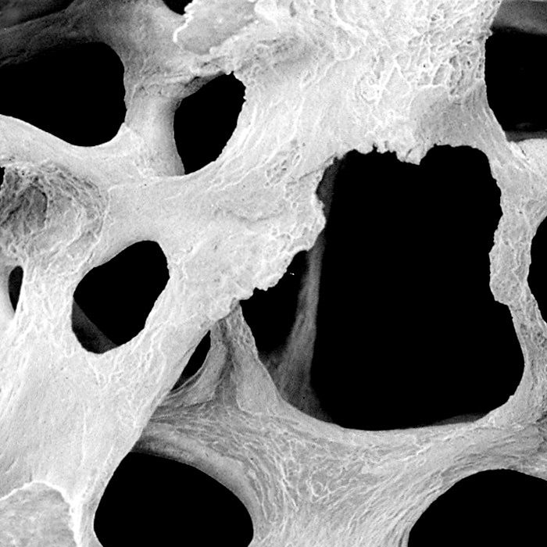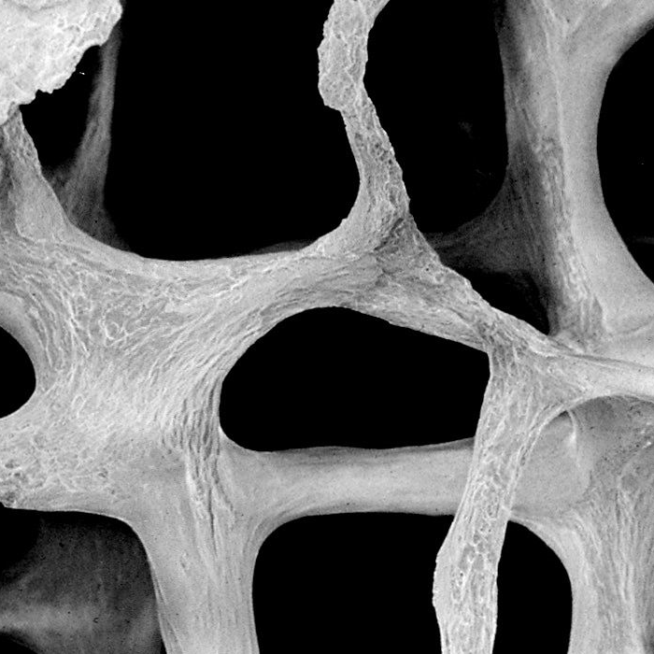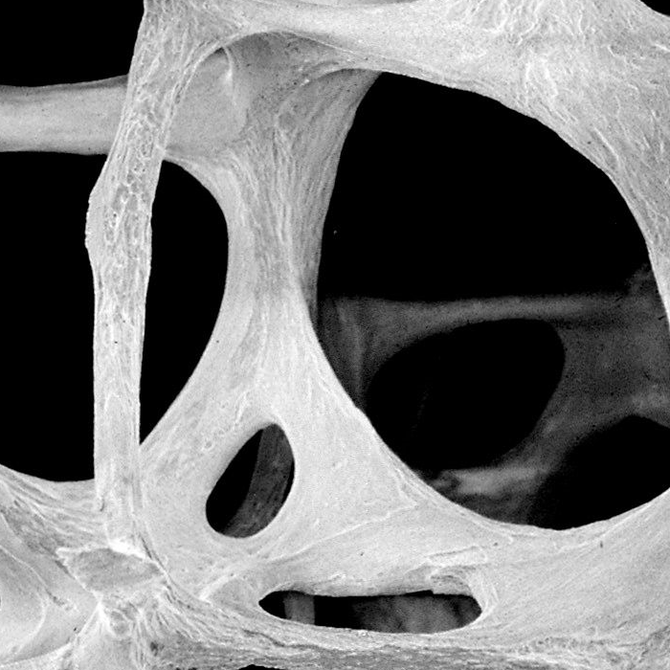

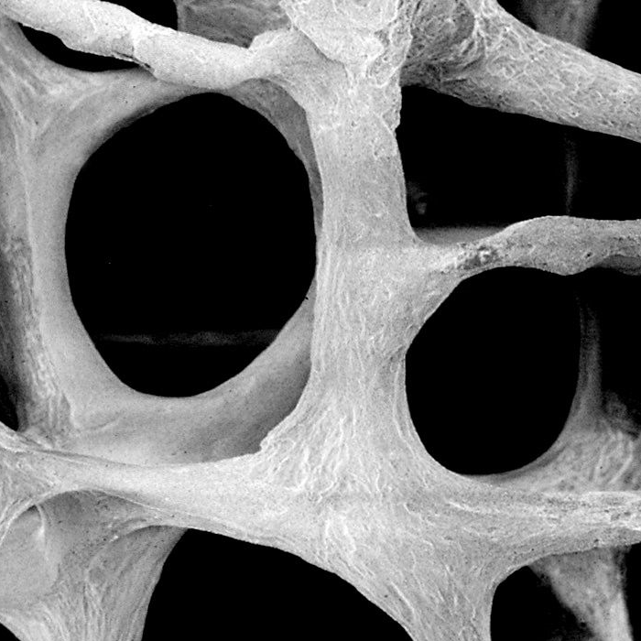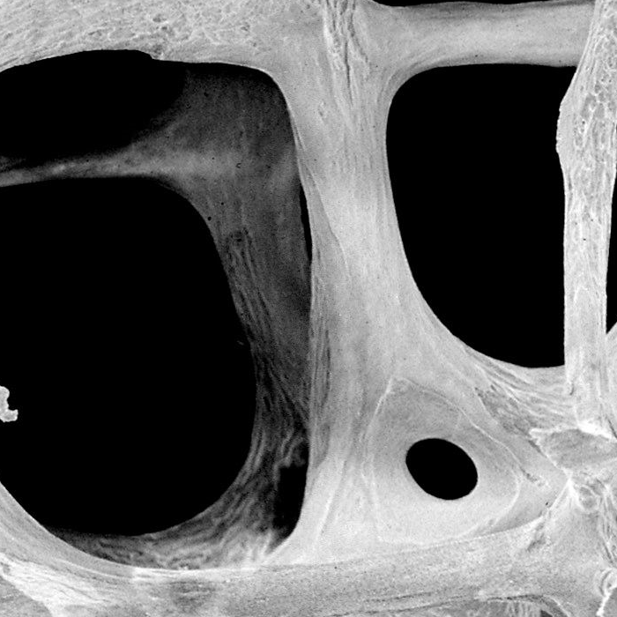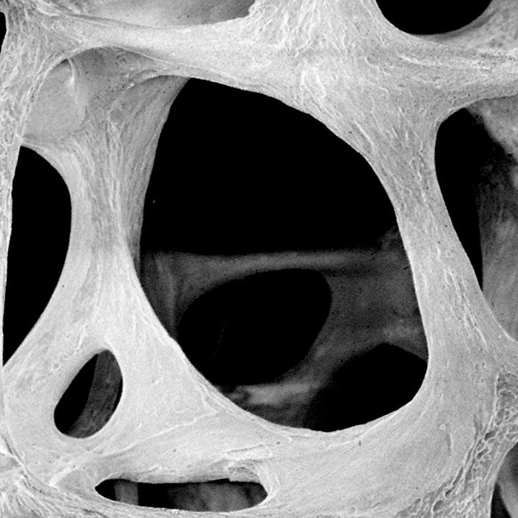

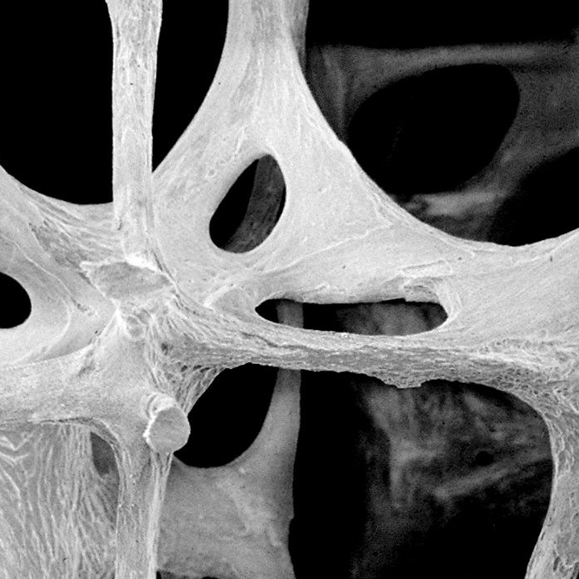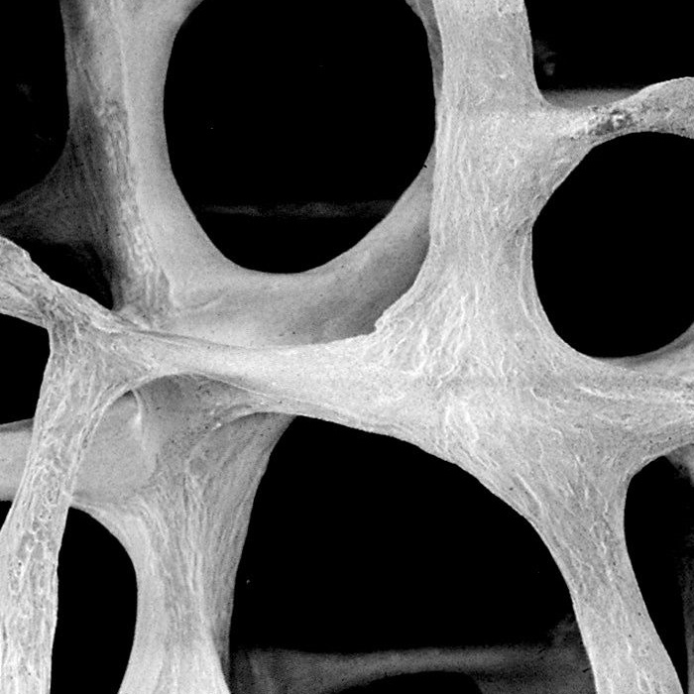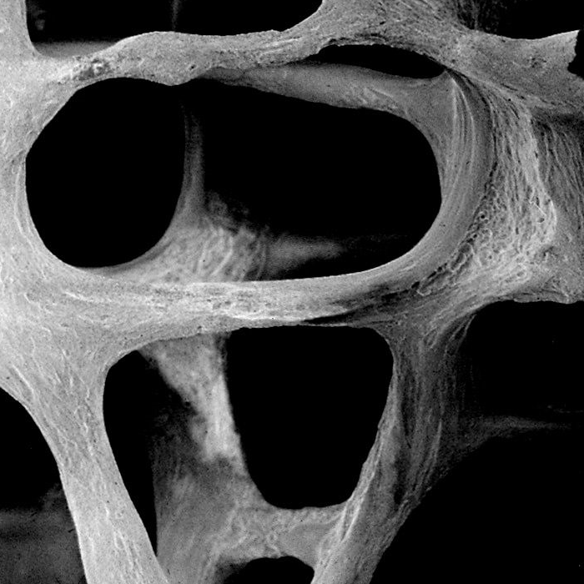

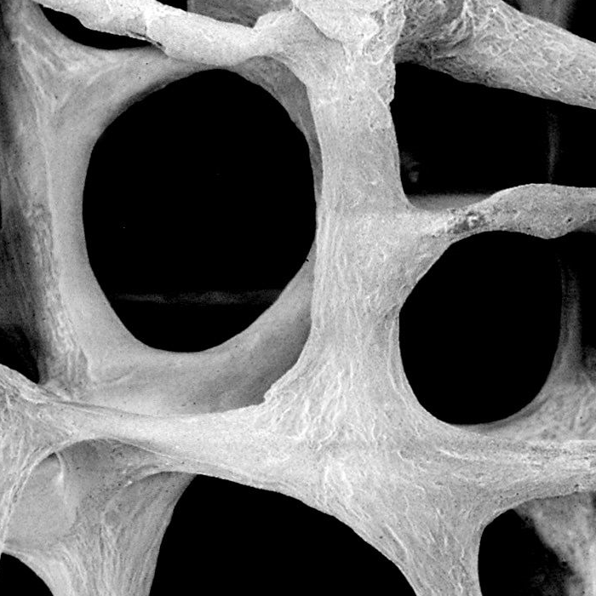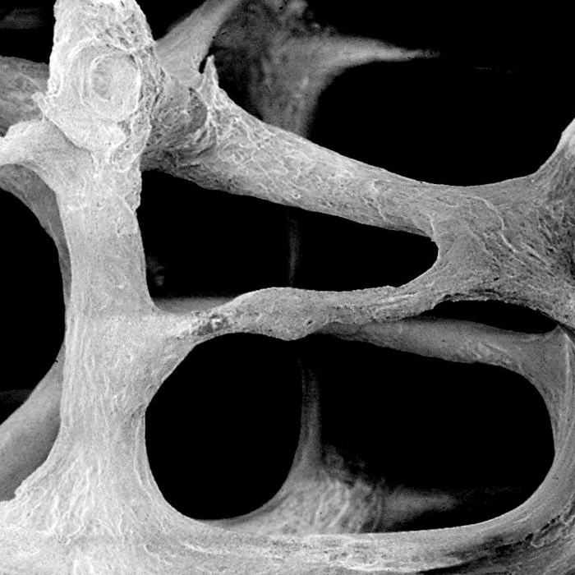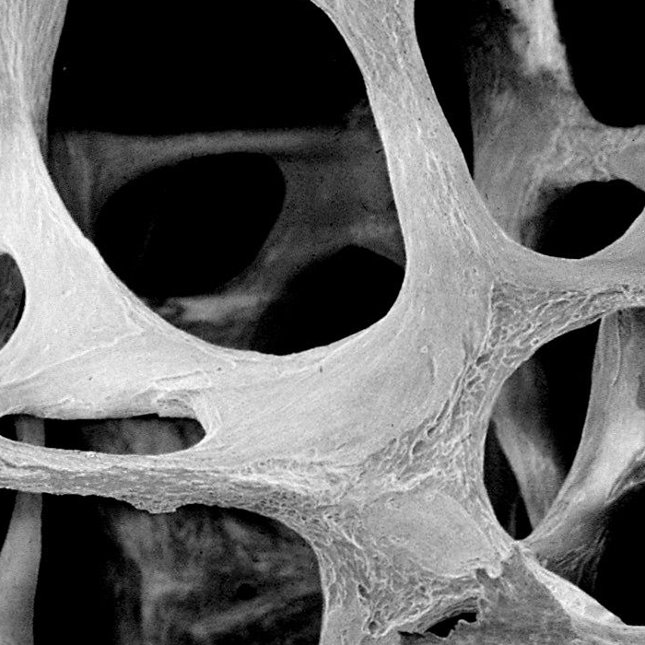

*Figures 1.1 to 1.12: Scanned electron image of samples of significance*

*Conclusion*

The results conclusively determine that the samples discovered on the surface of Mars are indeed fossilized bones. While the analysis run for this experiment concludes the samples collected are fossilized bone, it is of our opinion that there may have been errors in the result and we cannot confidently support the findings of this analysis.

**Procedure 2**

*Question*

Does the pelvis structure formed have any predictable functions?

*Introduction*

The fossilized bone samples recovered formed into two seemingly complete structures, the first of which being a pelvis-like structure that was then compared and analyzed against known pelvis structures of animal species on Earth. The Bone Comparison Database was used for this analysis, comparing the unnamed specimen’s “pelvis” against hundreds of thousands of pelvises from the database. Using a complex algorithm, animals with pelvis structures most closely matching our unnamed specimen’s pelvis were determined. From this list, a group of functions and possible habitat were postulated, as seen in the figure below.

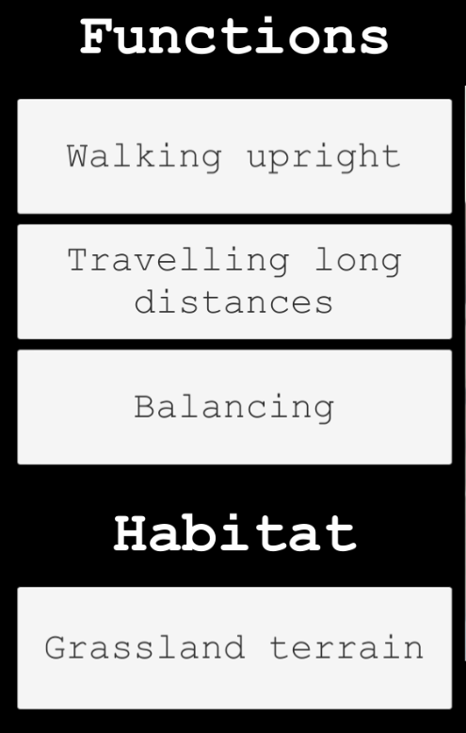

*Figure 2: Predicted functions and habitat of specimen from pelvis*

*Conclusion*

The results we found, outlined in the figure above, summarize that this unknown creature had a pelvis-like bone structure with functions similar to known mammals on Earth, suggesting it evolved to adapt to its relatively low-shrubbed, grassland terrain. While the analysis run for this experiment concludes the functions and habitat for this specimen’s pelvis, it is of our opinion that there may have been errors in the result and we cannot confidently support the findings of this analysis.

**Procedure 3**

*Question*

Does the hand structure formed have any predictable functions?

*Introduction*

The fossilized bone samples recovered formed into two seemingly complete structures, the second being a hand-like structure that was then compared and analyzed against known hand structures of animal species on Earth. The Bone Comparison Database was used for this analysis, comparing the unnamed specimen’s “hand” against hundreds of thousands of hands from the database. Using a complex algorithm, animals with hand structures most closely matching our unnamed specimen’s hand were determined. From this list, a group of functions and further details on the specimen’s possible habitat were postulated, as seen in the figure below.

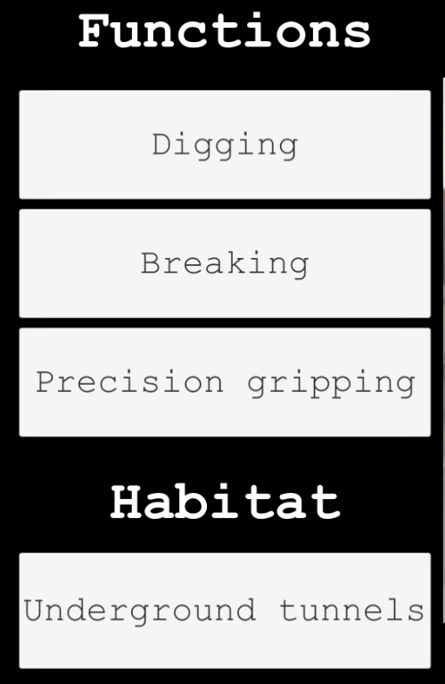

*Figure 3: Predicted functions and habitat of specimen from hand*

*Conclusion*

These results we found, outlined in the figure above, summarize that this unknown creature had a hand-like bone structure with functions similar to known mammals on Earth, suggesting it evolved to adapt to burrow in its underground environment. While the analysis run for this experiment concludes the functions and habitat for this specimen’s hand, it is of our opinion that there may have been errors in the result and we cannot confidently support the findings of this analysis.

**Procedure 4**

*Question*

Are these fossils really from Mars, or could they have been placed there from Earth?

*Introduction*

While the samples prove to be that of fossilized bone and the completed structures provide further insight into the evolved forms of the specimen, it must also be determined whether these samples truly came from Mars. Could these samples possibly have been from Earth and at some point placed on Mars? Or does the evidence suggest that this specimen originated from Mars? An analysis of the sample’s carbon composition could provide further insight into the diet of the specimen and what water sample that diet most closely matches. Analyzing the specimen’s teeth found amongst the fossil samples, an ice sample collected on Mars, and an ice sample collected on Earth resulted in the following breakdown of carbon composition.

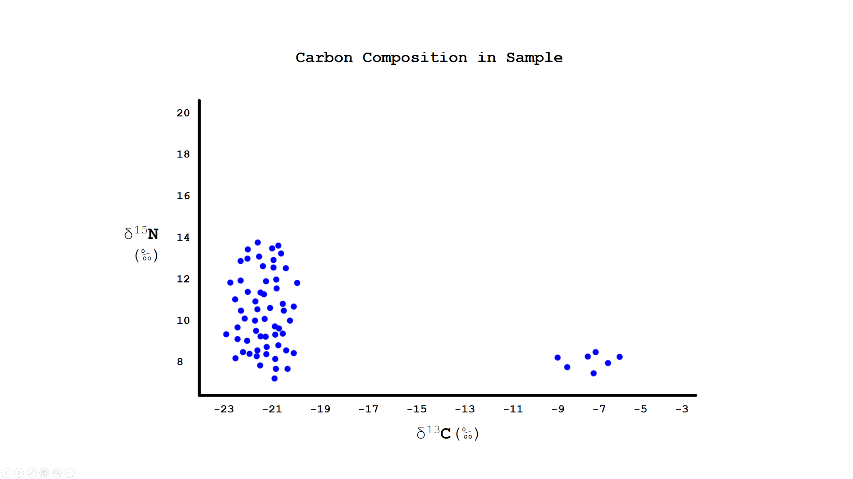

*Figure 4.1: Carbon composition of teeth fossil*

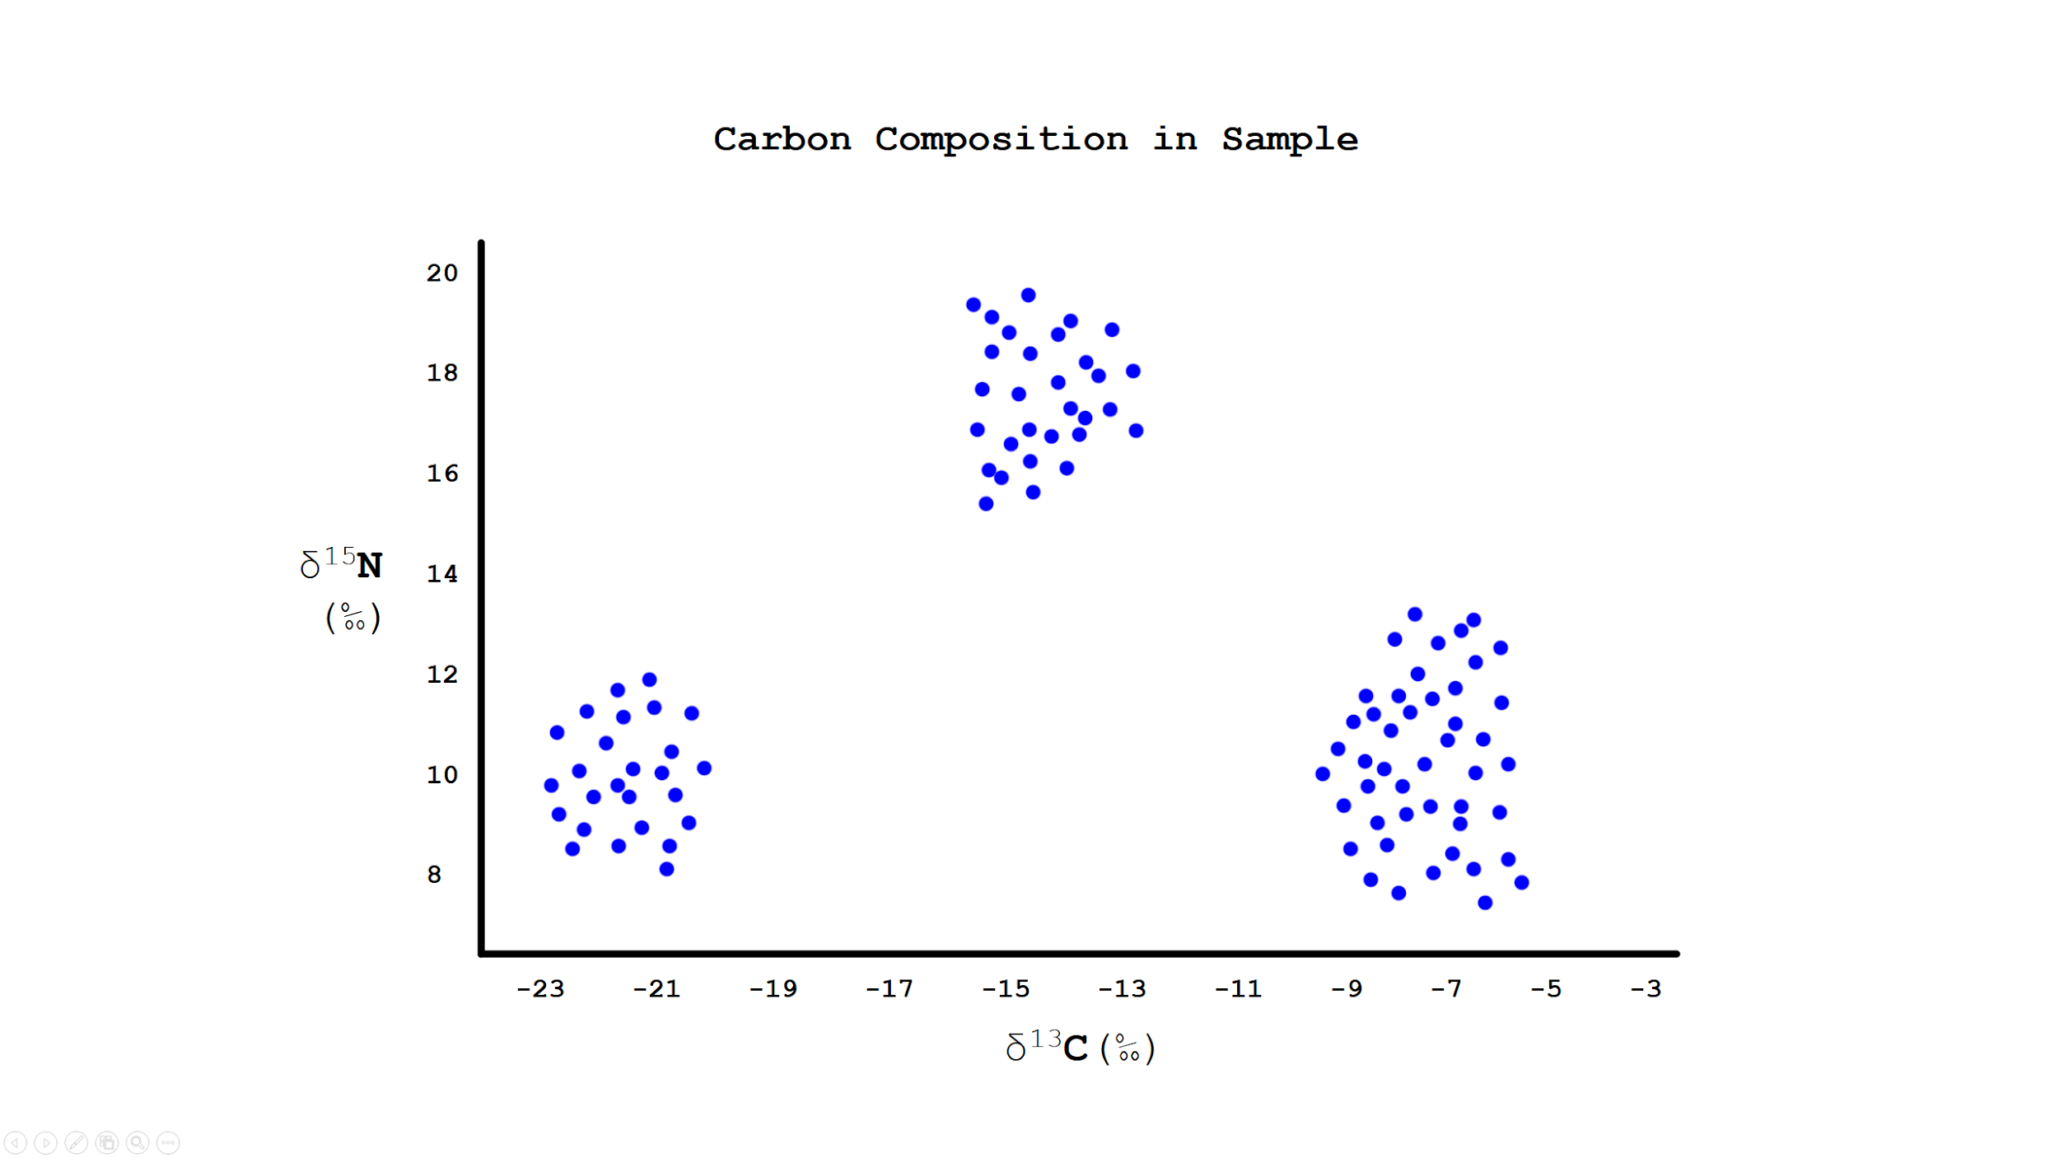

*Figure 4.2: Carbon composition of ice from Earth*

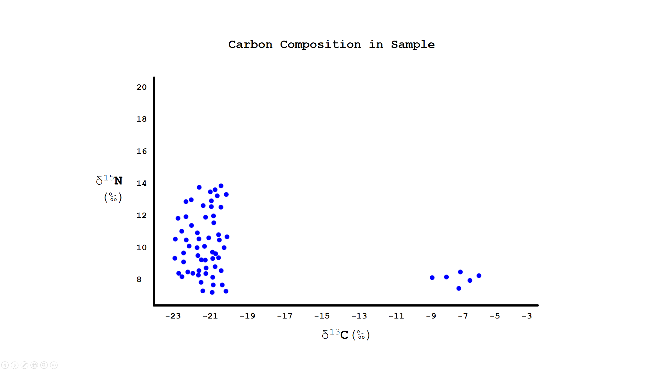

*Figure 4.3: Carbon composition of ice from Mars*

*Conclusion*

The results found and collected in the figures above conclude the fossilized teeth found in the collected samples share no common carbon composition with ingestible water found on earth, but do share a composition similar to ice samples found on Mars, suggesting the specimen originated from Mars. While the analysis run for this experiment concludes the samples found originated on Mars, it is of our opinion that there may have been errors in the result and we cannot confidently support the findings of this analysis.

**Procedure 5**

*Question*

Does the timeline of the origin of this specimen coincide with when it may have realistically existed?

*Introduction*

If this specimen was once a humanoid creature, living on Mars and adapted to its environment, then it must follow that the specimen must have existed during a time in which Mars was habitable for any life form. Given the findings of past studies, this time period would have existed approximately 3 billion years ago at the start of the Amazonian Period, before the atmosphere on Mars began to thin and while there was still flowing water on the surface and in caves below. Using lead-uranium dating of a sample collected from the surface of Mars, the following information was gathered:

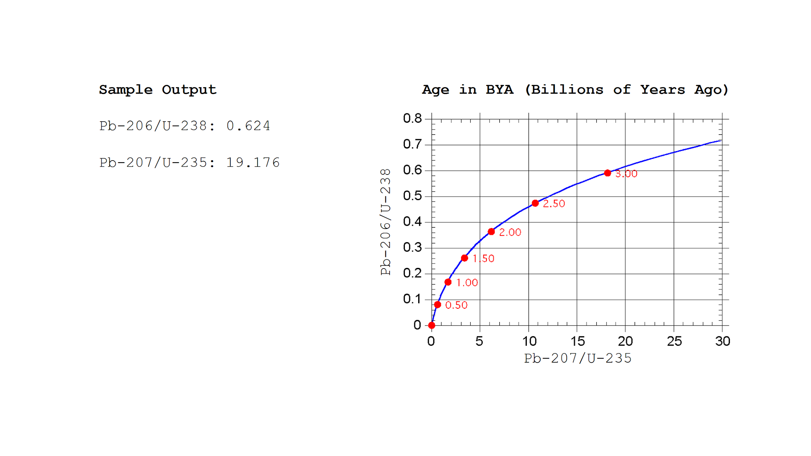

*Figure 5: Age Dating of sample using lead-uranium method*

*Conclusion*

These results conclude the samples found on Mars can be dated to roughly 3 Gya (billion years ago), coinciding with the time period where it has been previously theorized that Mars may have supported life. While the analysis run for this experiment concludes the specimen dates back to a time when Mars may have plausibly held life, it is of our opinion that there may have been errors in the result and we cannot confidently support the findings of this analysis.